**Basic DBS check process:**

For your current role at the National Deaf Children’s Society, you are required to complete a basic DBS check. Please follow the process below.

There is a cost of £25. As you will be able to claim this back, please ensure you take a screen shot of the payment page as confirmation of payment.

**How to apply for a basic check**

DBS provides this service if you’re living or working in England or Wales.

You can apply directly through DBS using the online application route. Please follow this link:

<https://www.gov.uk/request-copy-criminal-record>.

Please read the information carefully on the page and when you are ready with all the required information and documents, click on **“Start Now”.**

**On the next page, please tick both the boxes (once you have read the DBS privacy policy) and then click on “Continue to GOV.UK Verify”**

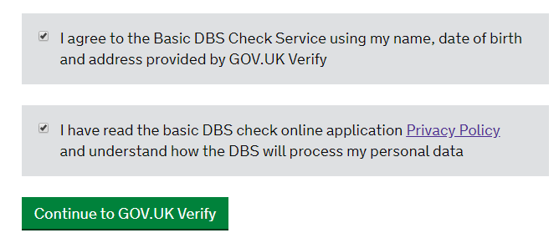

Please tick the relevant box depending on whether you have used GOV.UK Verify before.

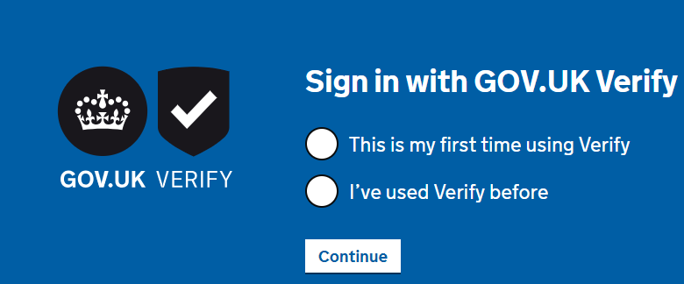

If you have used GOV.UK Verify before, you will then be asked to select and login to your Identity account with the relevant company. Please complete the process on their website.

If you have not used GOV.UK Verify before, you will need to create an account with one of the companies listed on the page. Please do so and complete the process on their website.

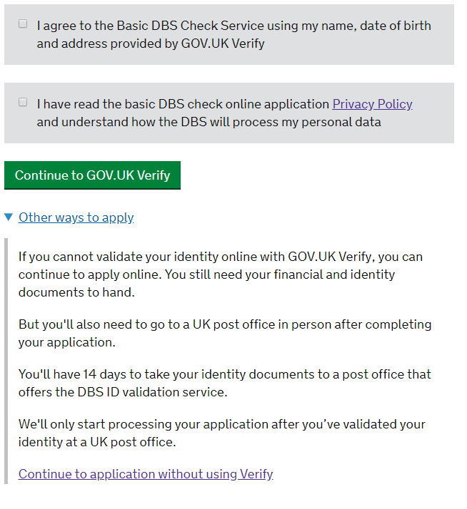

**Please remember to take a print screen of the final step confirming your payment and submission of your application in order for us to reimburse you. Please complete the expense claim process on Concur to get this refunded to you. If you are a new starter you will complete the claim process once you have joined the organisation.**

**IMPORTANT:**

**If for any reasons you are unable to complete the procedure online, please go back to the below page and click on “Other ways to apply”.**

**Please send us the online code once you receive it so we can verify your certificate online.**

**If you are unable to generate the online code please send me a copy of your certificate on this occasion. You will need to bring the original once we are back to the office.**

**Please note that we do not keep copies of certificates, only certificate number and issue date. The copy of your scan will be deleted securely and will not be held on our records.**

**19/03/2020**